Lab Task Week 09-Part02

Objective:
- Upload a notebook file
- Upload data (Excel) file
- Read data from data file
- Clean the data.

Note: You need to download the files from BBLearn.
- Lab_Task.ipynb and
- Marks.xlsx

- Open your google chrome browser
- Go to the website https://colab.research.google.com/
- Press the Sign in Button on top right and sign in to your google account.
- Select upload notebook from the File menu and drag/drop the Lab_Task.ipynb file from your computer.
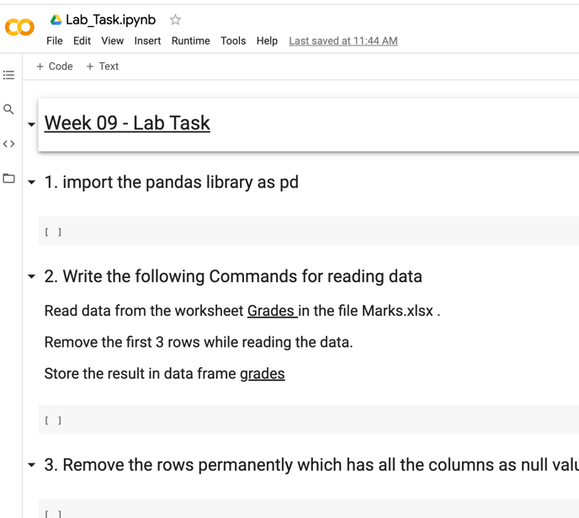

- Click on the files option from the tool menu to add the data file.
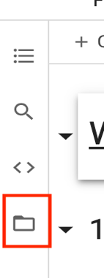

Note: Wait till the runtime is connected to see the options of file.

- Click on the upload option and choose the marks.xlsx to upload it with the project.
Note: Uploaded files will get deleted when this runtime is recycled. You need to reupload it if runtime is recycled.

- To upload the data file | - After data file is added
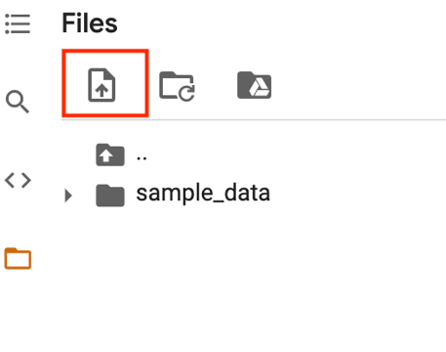 | 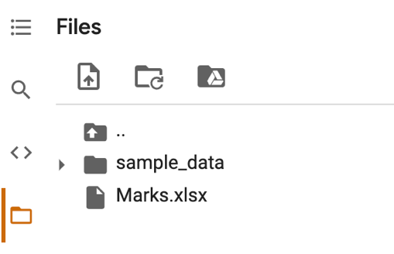

- Complete the below Lab Tasks and type the code in given space.

a. | Import the pandas library as pd
b. | Complete the following in one command.  Read data from the worksheet Grades in the file Marks.xlsx.  Remove the first 3 rows while reading the data.  Store the result in data frame grades
c. | Remove the rows permanently which has all the columns as null value
d. | Replace all the null values to 0 permanently
e. | Change the column name ID (with one space after ID) to ID (without space) and Final to FWA permanently

- Download the notebook to your local computer.

